LAB 02

Task 01:

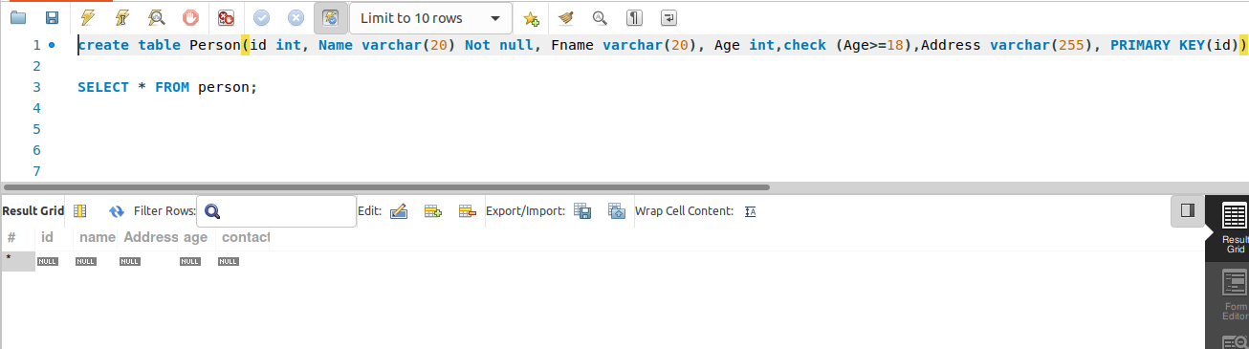

Task 02:

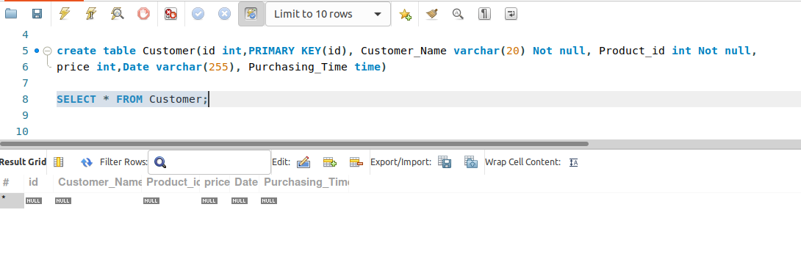

Task 03:

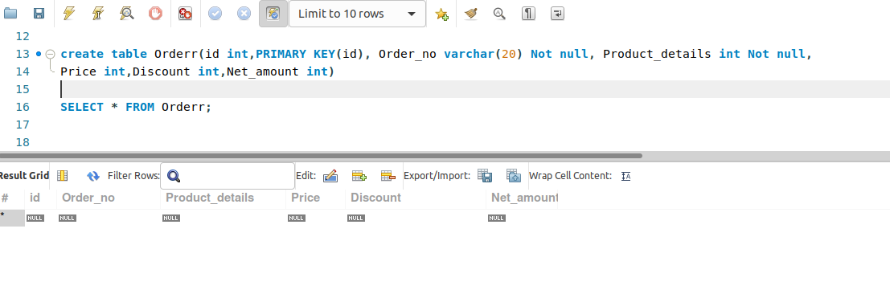

Task 04:

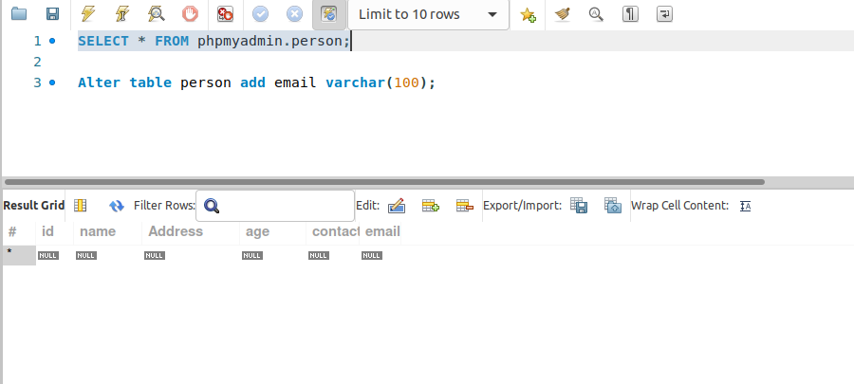 Task 05:

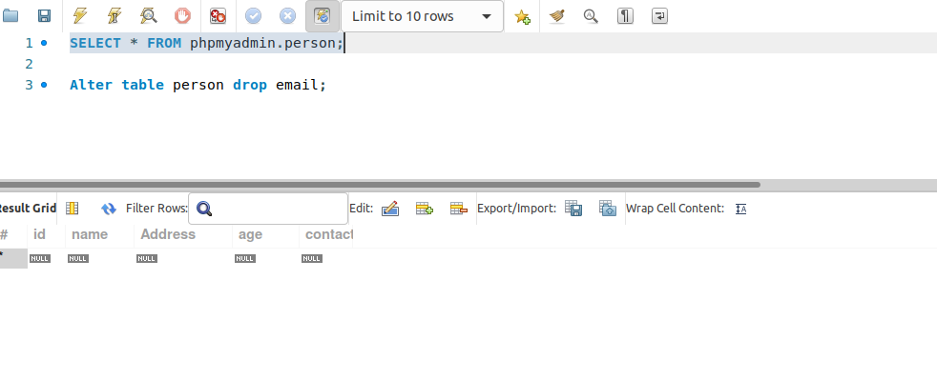LAB 03

Task 01: